Escoffier’s model for inlet stability is depicted in the below figure.

On the horizontal axis is the entrance cross-section and on the vertical axis is the maximum cross-sectionally averaged velocity in the inlet.

The velocity *ueq* is the equilibrium inlet velocity.

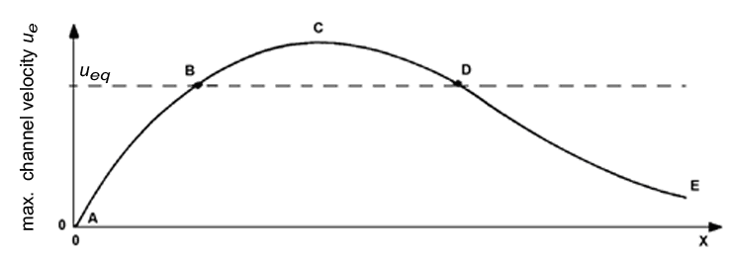

Now consider an inlet system in dynamic equilibrium.

In order to accommodate larger ships there is a wish to obtain a larger stable cross-section.

*Of the below options, what is a workable engineering solution?*

|  |  |  |
| --- | --- | --- |
|  |  | Enlarge the cross-section by dredging until the desired size. Nature will maintain this enlarged cross-section. |
|  |  | Slightly enlarge the cross-section by dredging such that it is at section B-C-D. Nature will now further enlarge it. |
|  |  | Enlarge the cross-section and at the same time build hard structures that move point D to the right. |

In the following picture, the horizontal tide is shown as the sum of M2 and M4 tidal constituents: *u*(*t*)=*ûM2*cos(*ωM2t*)+*ûM4*cos(*ωM4t*-*φ*)  .

The velocity axis is positive upward and velocities are defined positive in wave propagation direction. The time axis is positive to the right.

|  |  |  |  |  |  |  |  |
| --- | --- | --- | --- | --- | --- | --- | --- |
|  | <https://mapleta-bsprod1.tudelft.nl:8443/mapleta/web/Cie4305000/Public_Html/HorTide1.png> |  | <https://mapleta-bsprod1.tudelft.nl:8443/mapleta/web/Cie4305000/Public_Html/HorTide2.png> |  | <https://mapleta-bsprod1.tudelft.nl:8443/mapleta/web/Cie4305000/Public_Html/HorTide3.png> |  | <https://mapleta-bsprod1.tudelft.nl:8443/mapleta/web/Cie4305000/Public_Html/HorTide4.png> |

   
*Of the four above resulting velocity signals (dotted lines) which one gives rise to the export of normal to coarse sediment out of a basin?*

Consider a short tidal basin in dynamic equilibrium.

The flood-tidal delta spans the entire basin area.

Now suppose that a relatively shallow part of the basin is reclaimed, reducing the basin area with a certain percentage.

Immediately after the closure the tidal flats are already more or less in equilibrium.

*Relatively short after the closure:*

|  |  |  |
| --- | --- | --- |
|  |  | the tidal velocity signal in the inlet gorge has become more ebb-dominant: TRUE |
|  |  | the tidal velocity signal in the inlet gorge has become more ebb-dominant: FALSE |
|  |  | the ebb-tidal delta is eroding: TRUE |
|  |  | the ebb-tidal delta is eroding: FALSE |

Escoffier’s model for inlet stability is depicted in the below figure.

On the horizontal axis is the entrance cross-section and on the vertical axis is the maximum cross-sectionally averaged velocity in the inlet.

The velocity *ue* is the equilibrium inlet velocity and three different closure curves are shown.

The dots indicate equilibrium conditions.

Escoffiers model can be seen as a morphodynamic model for the entrance of tidal basins.

The perturbation of an equilibrium may either result in positive or negative feedback.

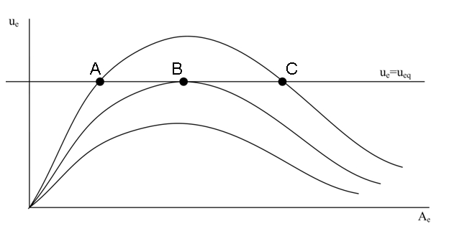

|  |  |  |
| --- | --- | --- |
|  |  | Point A shows an equilibrium condition that leads to positive feedback: TRUE |
|  |  | Point A shows an equilibrium condition that leads to positive feedback: FALSE |
|  |  | Point B represents a condition of stable equilibrium: TRUE |
|  |  | Point B represents a condition of stable equilibrium: FALSE |
|  |  | For Point C equilibrium relationships relating the cross-sectional inlet area to the tidal prism can be expected to hold: TRUE |
|  |  | For Point C equilibrium relationships relating the cross-sectional inlet area to the tidal prism can be expected to hold: FALSE |

As a result of the tidal flow being diverted around a long shore-normal breakwater, the streamlines of the tidal flow will exhibit a certain curvature.

Due to this curvature, a secondary current may be expected.

*Such a secondary current:*

|  |  |  |
| --- | --- | --- |
|  |  | is directed along the streamlines of the tidal flow |
|  |  | is directed normal to the streamlines, with more or less onshore velocities near the bed |
|  |  | is directed normal to the streamlines, with more or less offshore velocities near the bed |
|  |  | none of the other answers |

Consider the below signal of the horizontal tide in a tidal basin.

The velocities are defined positive in wave propagation direction.

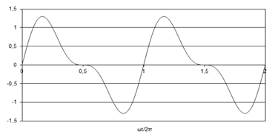

*What is the direction of the net tide-averaged transport of fine sediment?*

|  |  |  |
| --- | --- | --- |
|  |  | landward directed |
|  |  | seaward directed |
|  |  | no net transport |

The below picture shows a sketch of the morphological units of a tidal inlet system at a barrier island coast.

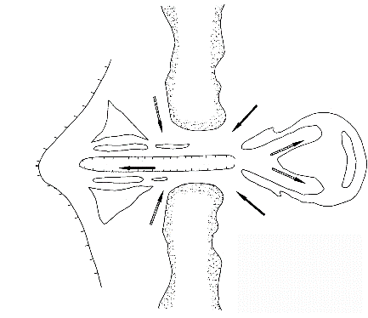

*Which arrows indicate ebb flow?*

|  |  |  |
| --- | --- | --- |
|  |  | Solid arrows |
|  |  | Hashed arrows |

The below hypsometric curves for two different basin types show the wetted basin surface area O(z) as a function of the water level.

|  |  |  |  |
| --- | --- | --- | --- |
|  | https://mapleta-bsprod1.tudelft.nl:8443/mapleta/web/Cie4305000/Public_Html/hypsoLeft.png |  | https://mapleta-bsprod1.tudelft.nl:8443/mapleta/web/Cie4305000/Public_Html/hypsoRight.png |

*Which of the two basin types is more likely to result in sediment export of normal to coarse sediment?*

A basin is in dynamic equilibrium.

At some point in time, part of the basin is closed off by a dam.

The closure did not affect the tidal prism.

However, the dynamic equilibrium of the basin was disturbed in such a way that the basin started importing sediment.

*What will after some time be the effect of the closure, if any, on the adjacent coastlines?*

|  |  |  |
| --- | --- | --- |
|  |  | Accretion of the updrift coastline |
|  |  | No effect |
|  |  | Accretion of the downdrift coastline |
|  |  | Erosion of the downdrift coastline |
|  |  | Erosion of the updrift coastline |